Question : 1
Create a Python list to represent a playlist of 5 song durations in seconds (e.g., [210, 180, 245, 200, 175]). Print the total duration of the playlist :

playlist =[210,180,245,200,175]
total_duration =sum(playlist)
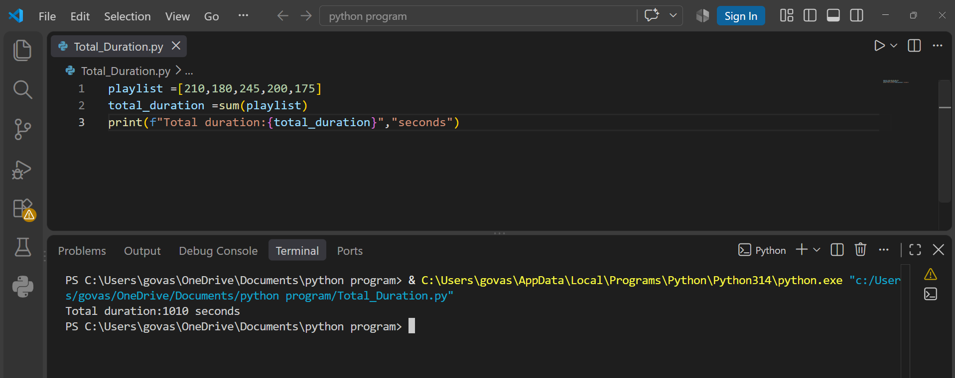
print(f"Total duration:{total_duration}","seconds")

Question : 2
Represent a 3x3 matrix in Python to store the ratings (1-5) given by 3 friends to 3 different food items on Swiggy. Print the matrix and display the rating each friend gave to the second food item : “ 3 friends rating 3 different food items ”
ratings =[
[5,4,3],
[4,5,4],
[3,4,5]]
print("Rating Matrix:")
for row in ratings:
print(row)
print("Ratings for the second food item:")
for i in range(3):
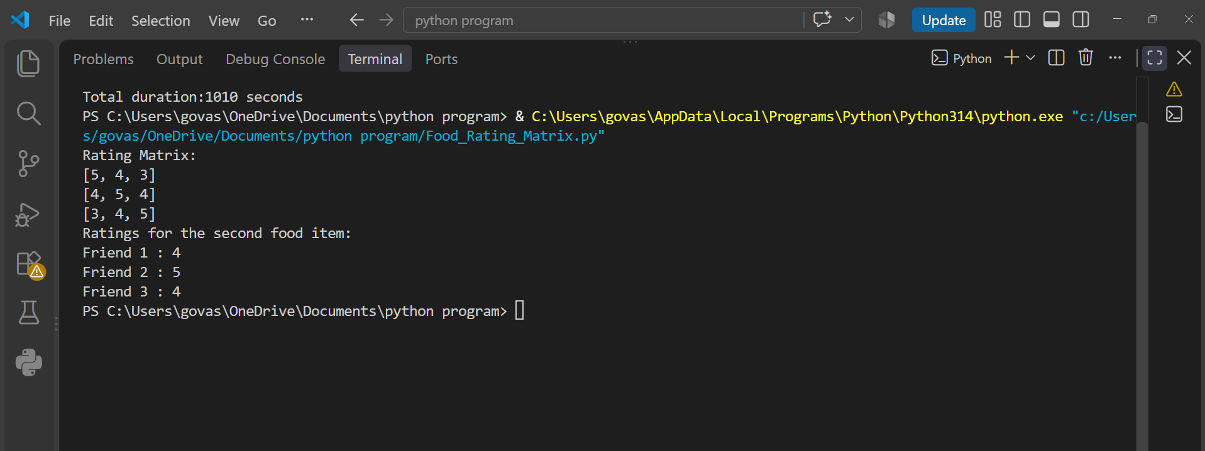
print("Friend",i + 1, ":",ratings[i][1])

Question : 3
Given a matrix representing the number of orders for 4 different dishes across 3 days (rows: days, columns: dishes), write code to calculate and print the total orders for each dish :
Rows =days ,Columns =dishes
orders = [[10,15,20,12],
[12,18,15,10],
[8,20,17,15]]
total_orders =[0,0,0,0]
for row in orders:
for j in range(4):
total_orders[j] += row[j]
print("Total orders for each dish:")
for i in range(4):
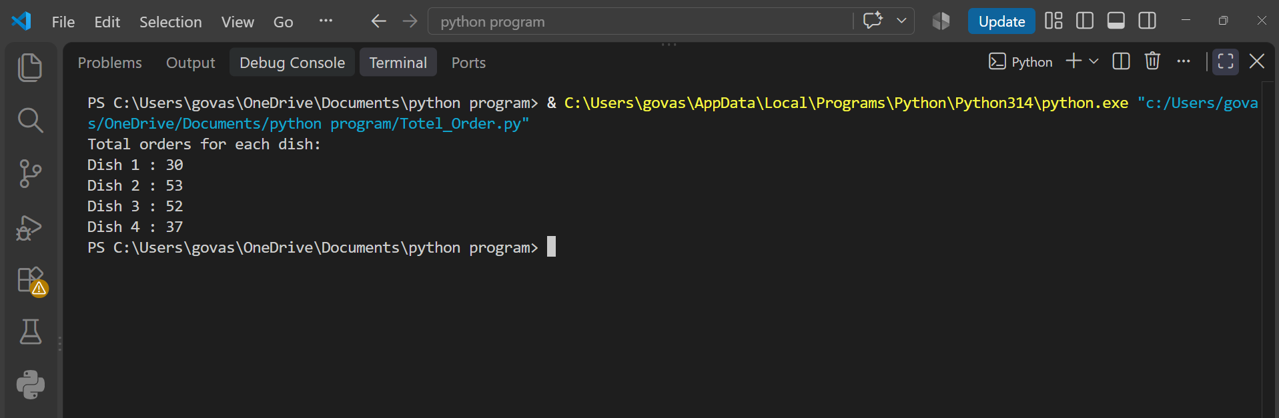
print("Dish",i + 1,":",total_orders[i])

Question : 4
Imagine you have a table of 5 Flipkart products with columns for price and quantity sold. Represent this data as a matrix in Python, then write a function to calculate the total revenue for each product.<br><br><em><strong>Hint:</strong> Multiply price and quantity for each row, then print the results : </em>

[Price, Quantity Sold]
products =[[500,10],
[1200,5],
[750,8],
[2000,3],
[300,15]]
def calculate_revenue(products):
for row in products:
price =row[0]
quantity =row[1]
revenue =price * quantity
print("Total Revenue:",revenue)

calculate_revenue(products)

